
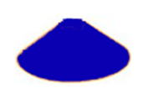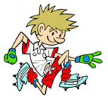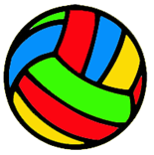
RULES – HOW TO PLAY

Children start at the dome

They pick up a cone and place a medium sized ball on top of it to make an ice-cream shape

Holding the ice-cream using hands, children must walk along the line/rope/bench maintaining balance

When they reach the end of the line place ball in hoop and return to start

Next child repeats returning with ball

1 point awarded for completing the station

A bonus point for keeping the ball/bean bag balanced

FOCUS
The focus of this activity is to challenge the children to maintain balance while travelling along a straight line while carrying an object

STATION 2: BALANCE
Activity: Ice Cream Run

HARDER
- Use rope, gym benches, stability discs etc. to travel on
- Challenge children to hold cone in 1 hand while travelling
- Place a bean bag or quoit on head while travelling
- Challenge children to travel sideways or back ways on line
- Can they hop, jump etc. as they move?

EASIER
- Travel across line without ice-cream, arms out for balance
- Carry ice-cream moving from one cone to another, no rope

COACHING POINTS

HEAD
- Eyes scanning area in which travelling, in order to plan next foot position

HANDS
- If 1 hand on ice-cream other arm out to side to maintain balance

FEET
- Place one foot in front of the other and make sure balance is maintained before moving foot for next step

EQUIPMENT
- 1 x Skipping Rope / 1 x Piece of chalk (straight line)
- 1 x Dome
- 1 x Medium cone
- 1 x Medium sized ball
- 1 x Hoop
- 1 x Bean bag / quoit

Copyright Ulster Council GAA 2009

